Title comprehensive digital marketing for Mahindra & Mahindra Ltd

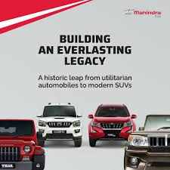

Introduction:

Comprehensive digital marketing for Mahindra & mahindra
To create a comprehensive digital marketing strategy for Mahindra & Mahindra Ltd., you’ll want to tailor the approach to their diverse product lines (automotive, farm equipment, construction, etc.) and global presence. Here’s a structured plan:

Brand study, competitor analysis & Buyer's and audience persona
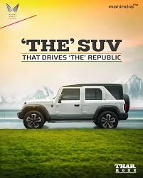

Rearch brand identity
- Reaching and reinforcing Mahindra & Mahindra's brand identity requires a strategic approach that reflects its core values, legacy, and markepositioning while adapting to modern consumer expectations. Here’s how you can refine and strengthen the brand identity:

Brand study :
M&M's brand is synonymous with durability, innovation, and value for money. The company emphasizes reliability and performance, particularly in challenging conditions, and has made significant aelectric vehicles and technol technocampaigns .

Competitor Analysis
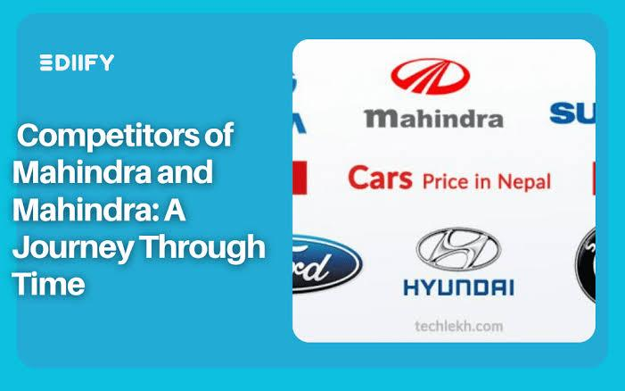
- In the Indian automotive landscape, M&M faces competition from several key players:
- Tata Motors: Offers a wide range of vehicles, from commercial trucks to passenger cars, and has a significant market presence.
- Maruti Suzuki: Dominates the passenger car .
Hyundai: Strong in the SUV and hatchback segments, known for innovative designs and features.
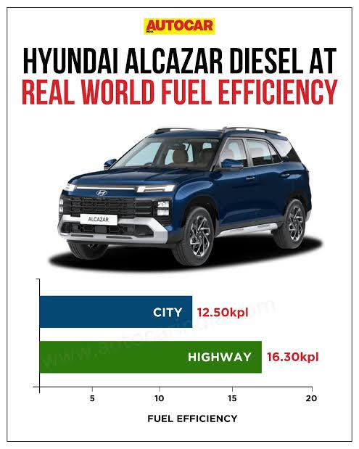
Toyota: Recognized for reliability and a strong performance in the SUV and luxury segments.
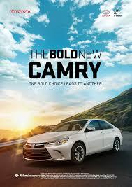
M&M holds a significant share in the SUV and tractor segments, distinguishing itself through a diverse portfolio that includes electric vehicles, showcasing its commitment to innovation and sustainability.
- M&M caters to various customer segments, each with distinct characteristics:

1. Urban SUV Buyers:
- Demographics: Aged 28-45, married, mid to high-income urban households.
- Needs: Seek performance, prestige, and distinctive style; an SUV aligns with their active lifestyle.
Rural Farmers:
- Demographics: Male, mid-income, owns over 2 acres of farmland, married with children.
- Needs: Require reliable, fuel-efficient, and powerful tractors for intensive farming; financing .
- Values: Budget-conscious yet progressive; take pride in their farm's prosperity.

2.Commercial Fleet Owners:
- Demographics: Aged 35-50, own fleets of light commercial vehicles (LCVs).
- Needs: Seek vehicles with low operating costs, good service support, and favorable financing options.
- Values: Focus on business growth and profitability; expect good value for money.

3. Rural Farmers:
- Demographics: Male, mid-income, owns over 2 acres of farmland, married with children.
- Needs: Require reliable, fuel-efficient, and powerful tractors for intensive farming; financing options are important.

1.Brand Core Elements
✅ Mission:
"To drive positive change and enable people to rise by empowering them with world-class mobility and agricultural solutions."
✅ Vision:
"To be a global leader in mobility, farm, and construction solutions by delivering superior value through innovation and sustainability."
✅ Brand Values:
Rise: Embodying the spirit of innovation and resilience.
Trust: Built over decades through reliable performance.

2. Brand Personality
- Position Mahindra as a brand that is:
- Reliable – Known for durable products and trusted service.
- Innovative – Focus on cutting-edge technology and design.

3. Brand Voice and Tone
- Tone: Confident, straightforward, and inspirational.
- Voice: Authoritative yet approachable.
- Language: Use strong, action-oriented language

4. Visual Identity
- 🎯 Logo & Colors:
- Logo: Keep the existing Mahindra logo to maintain recognition but refine its modernity if needed (e.g., sharper edges, refined color palette).
Colors:
- Red – Passion, strength, and leadership.
- Black and Grey – Professionalism and durability.
- Green (for agriculture line) – Sustainability and growth.
🎯 Typography:
- Use bold, clean fonts that reflect strength and modernity (e.g., Montserrat, Roboto).
- Maintain consistency across all platforms (digital, print, product packaging).

5. Brand Story
- 🔥 Heritage Meets Innovation
- Craft a compelling narrative that blends Mahindra’s long history with its future-forward vision:
- Focus on technological breakthroughs (e.g., electric vehicles, smart farming solutions).

6. Product Line Extensions
- SUVs: Adventure-focused and luxury-positioned for urban markets.
- Tractors: Performance and durability-focused for rural markets.
- Electric Vehicles: Sustainability and innovation-focused for eco-conscious consumer's

7. Emotional Connection with Customers
- Automotive: Focus on the feeling of freedom and adventure (e.g., “Explore without limits”).
- Agriculture: Focus on empowering farmers and improving lives (e.g., “Strength to grow”).

8. Brand Consistency
- Ensure the identity is reflected consistently across:
- Website – Clean, modern design with intuitive navigation.
- Social Media – Strong visuals and consistent messaging.

1. Automotive Sector
Mahindra is a leading player in SUVs and electric vehicles, but faces strong competition from both domestic and global brands.

🚗 Key Competitors:

✅ Mahindra’s Competitive Edge:
- Strong foothold in SUVs with models like XUV700 and Thar.
- Pioneer in electric SUVs with the XUV400.
- Brand strength in off-road and adventure-focused vehicles.

🎯 Opportunities:
- Expand EV offerings to compete with Tata and Hyundai.
- Improve urban market penetration to challenge Maruti Suzuki and Kia.
- Enhance in-car technology and customer experience.

2. Agriculture Sector (Tractors)
Mahindra is the world’s largest tractor manufacturer by volume, but the competitive landscape is intense.

🚜 Key Competitors:

✅ Mahindra’s Competitive Edge:
- Leadership in the domestic market with tractors like Mahindra Arjun.
- Strong rural presence and customer loyalty.
- Competitive pricing and reliable after-sales service.

🎯 Opportunities:
- Develop smart tractors with IoT and AI capabilities.
- Expand in the US, Europe, and African markets.
- Introduce eco-friendly tractors (electric or hybrid).

3. Construction Equipment Sector
Mahindra’s construction equipment division is growing but faces stiff competition from global players.

🏗️ Key Competitors:

✅ Mahindra’s Competitive Edge:
- Competitive pricing and localized manufacturing.
- Strong support network and customer service.
- Expanding product range with high-performance equipment.

🎯 Opportunities:
- Develop electric or hybrid construction equipment.
- Focus on government infrastructure projects.
- Improve export reach to African and Asian markets.

4. Electric Vehicles (EV) and Sustainability
Mahindra has a strong start in the EV market, but competitors are scaling up quickly.

⚡ Key Competitors:

✅ Mahindra’s Competitive Edge:
- First-mover advantage with the eVerito and XUV400.
- Strong supply chain for battery and EV components.

🎯 Opportunities:
- Scale up EV production capacity.
- Introduce more affordable EV models.
- Partner with charging infrastructure companies.

✅ Strategic Recommendations:
- Automotive: Expand into urban markets with feature-rich models.
- Agriculture: Introduce AI and IoT-enabled tractors to maintain leadership.
- Construction: Focus on infrastructure projects and hybrid machinery.

Buyer's and audience’s persona

Creating a detailed buyer’s and audience persona for Mahindra & Mahindra will help refine marketing strategies, improve customer targeting, and create more effective campaigns. Here’s a breakdown of personas for automotive, agriculture, construction, and EV segments:

1. Automotive Sector – SUV and Passenger Vehicles
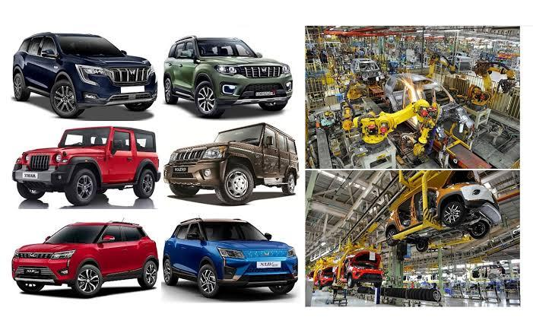
🚗 Persona 1: "Adventure-Seeker Arjun"
Age: 28–40
Gender: Male
Location: Urban and semi-urban areas
Income: ₹8L–₹20L per annum
Education: College graduate or professional degree
Occupation: Corporate professional, entrepreneur
Lifestyle:
Seeks adventure and freedom.
Values safety, technology, and comfort.
Buying Motivations:
Performance and ruggedness.
Off-road capability.
High-tech features (e.g., infotainment, driving assistance).
Pain Points:
Poor fuel efficiency.
Lack of premium feel.
Limited financing options.
🎯 Marketing Focus:
- Highlight off-road capability, premium interiors, and safety features.
- Promote adventure and lifestyle-based marketing .
- Use influencer marketing with automotive and travel bloggers.
🚗 Persona 2: "Family-Oriented Priya"
Age: 30–45
Gender: Female
Location: Urban and suburban areas
Income: ₹10L–₹25L per annum
Education: Postgraduate degree
Occupation: Professional, business owner
Lifestyle:
Focused on family safety and comfort.
Prefers a spacious, reliable, and safe vehicle.
Buying Motivations:
Safety ratings and family-friendly features.
Good after-sales service.
Pain Points:
High maintenance costs.
Poor fuel efficiency.
Lack of in-car entertainment for kids.

2. Agriculture Sector – Tractors and Farm Equipment

🚜 Persona 3: "Farmer Ramesh"
Age: 35–55
Gender: Male
Location: Rural and semi-urban areas
Income: ₹2L–₹8L per annum
Education: High school or lower
Occupation: Farmer or agricultural worker
Lifestyle:
Farming is the primary source of income.
Looks for reliability and low maintenance.
Buying Motivations:
Fuel efficiency and power.
Durability and reliability in tough conditions.
Pain Points:
High repair costs.
Difficult access to spare parts.
Poor customer service in rural areas.
🎯 Marketing Focus:
- Focus on local-language advertising and rural outreach programs.
- Highlight fuel efficiency, durability, and low maintenance
🚜 Persona 4: "Progressive Farmer Rajesh"
Age: 25–40
Gender: Male
Location: Semi-urban and rural areas
Income: ₹5L–₹12L per annum
Education: College-educated
Occupation: Agri-business owner or modern farmer
Lifestyle:
Interested in smart and automated farming.
Tech-savvy and open to innovations.
Buying Motivations:
Advanced technology and precision farming.
Low operational cost and high efficiency.
Financing options and government subsidies.
Pain Points:
High initial costs of smart farming equipment.
Poor internet connectivity for smart farming tools.
🎯 Marketing Focus:
- Promote smart tractors and IoT-enabled solutions.
- Leverage government subsidy awareness in rural areas.
3. Construction Sector – Heavy Equipment
🏗️ Persona 5: "Contractor Vinay"
Age: 30–55
Gender: Male
Location: Urban and industrial zones
Income: ₹10L–₹50L per annum
Education: Technical or engineering degree
Occupation: Construction business owner or contractor
Lifestyle:
Business-driven and profit-focused.
Requires high-performance, low-maintenance equipment.
Buying Motivations:
Reliability and strength of machinery.
Low maintenance costs and high productivity.
Good after-sales service and support.
Pain Points:
High repair and service costs.
Fuel consumption and environmental concerns.
🎯 Marketing Focus:
- Highlight strength, performance, and reliability.
- Emphasize low maintenance and fast service availability.
- Offer extended warranties and service contracts.
4. Electric Vehicle (EV) Sector
⚡ Persona 6: "Eco-Conscious Aman"
Age: 25–40
Gender: Male
Location: Urban areas
Income: ₹12L–₹25L per annum
Education: Postgraduate degree
Occupation: Professional, entrepreneur
Lifestyle:
Values sustainability and innovation.
Prefers cutting-edge technology and connectivity.
Buying Motivations:
Environmental impact.
Low running and maintenance costs.
Fast-charging and driving range.
Pain Points:
Lack of charging infrastructure.
High upfront costs.
Perceived battery life issues.
🎯 Marketing Focus:
- Focus on the eco-friendly aspect and cost savings.
- Partner with charging infrastructure providers.
✅ Strategic Recommendations:
- Develop product-specific content targeting each persona.
- Create separate social media campaigns for rural and urban markets.
- Use influencer and testimonial-based marketing to build credibility.

SEO& keywords rearch
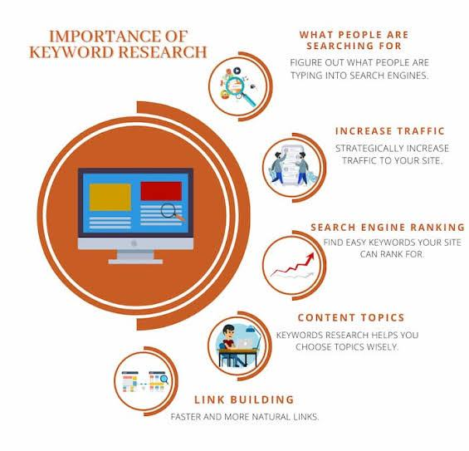
Conducting SEO and keyword research for Mahindra & Mahindra Ltd. across its key sectors (automotive, agriculture, construction, and EV) will help improve search visibility, drive organic traffic, and boost brand positioning. Here's a structured approach:

1. SEO Strategy for Mahindra

(A) On-Page SEO
- Optimize meta titles & descriptions with high-ranking keywords.
- Use schema markup for car models, dealership locations, and FAQs
- Improve internal linking across vehicle categories, blogs, and landing pages.

(B) Off-Page SEO
- Backlink building from automotive websites, reviews, and news portals.
- Collaborate with auto influencers and bloggers for guest posts and video reviews.
- Engage in social media marketing (YouTube, Instagram, LinkedIn) with trending hashtags.

(C) Technical SEO
- Optimize site speed and mobile-friendliness for better user experience
- Implement structured data for car specifications, reviews, and dealerships.

2.Content Strategy for SEO Growth
- To rank higher on Google, Mahindra should focus on SEO-driven content marketing, including:
(A) Blog Topics for Mahindra SUVs & EVs
✔ “Best SUVs for Off-Road Adventures in India”
✔ “Top 5 Upcoming Electric Cars in India (2025)”
✔ “Mahindra XUV700: Features, Price & Performance Reviews
(B) Blog Topics for Mahindra Tractors
✔ “How to Choose the Best Tractor for Your Farm”
✔ “Mahindra vs John Deere: Which Tractor is Right for You.
✔ “Fuel-Efficient Tractors for Indian Farmers”
(C) Blog Topics for Commercial Vehicles
✔ “Best Pickup Trucks for Small Businesses”
✔ “Mahindra Jeeto vs Tata Ace: Which One to Buy?”
✔ “How to Finance Your Commercial Vehicle in India”

3. Local SEO Strategy for Dealerships & Service Centers
- Optimize Google My Business (GMB) listings for all Mahindra dealerships.
- Include location-based keywords (e.g., “Mahindra SUV showroom in Delhi”).
- Get customer reviews and ratings to improve visibility.

Conclusion: Boosting Mahindra’s SEO Performance
By optimizing website content, targeting high-volume keywords, and leveraging local SEO, Mahindra can increase its online visibility, lead generation, and customer engagement.

Target Keywords:
Based on M&M's diverse product range and market segments, the following keywords are pivotal for their SEO efforts:
Automobiles:
- "Mahindra SUVs"
- "Mahindra Thar"
- "Mahindra XUV700"
- "Best SUVs in India"
- Electric Vehicles:
- "Mahindra electric vehicles"
- "Mahindra EV models"
- "Affordable electric cars in India"
- Tractors and Farm Equipment:
- "Mahindra tractors"
- "Best tractors for farming in India"
- "Mahindra agricultural equipment"

Commercial Vehicles:
- "Mahindra commercial vehicles"
- "Mahindra Bolero Pik-Up"
- "Best commercial vehicles in India"
- Recommendations for Enhanced SEO Performance:
1. Comprehensive Keyword Research: Regularly update keyword strategies to align with evolving search trends and consumer behavior.
3. Local SEO: Optimize for local search queries, especially for dealership locations, to attract nearby customers.
4. Mobile Optimization: Ensure the website is mobile-friendly, as a significant portion of users access content via mobile devices.

SEO Audit
Conducting a comprehensive SEO audit for Mahindra & Mahindra's official website (https://www.mahindra.com/) involves analyzing various aspects to enhance its online visibility and performance. Here's an overview based on available information.
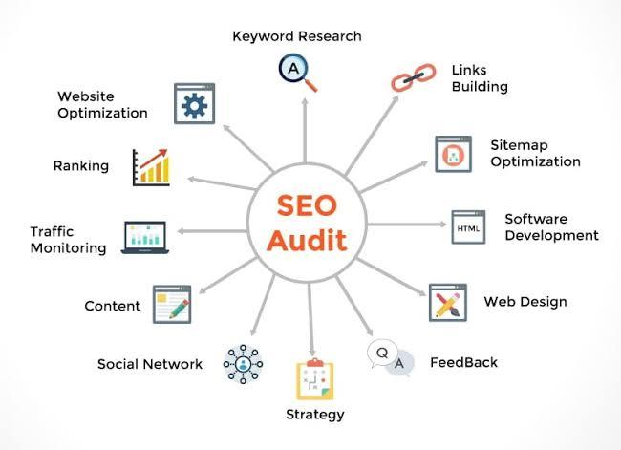
A comprehensive SEO audit for Mahindra & Mahindra involves analyzing technical SEO, on-page SEO, off-page SEO, and user experience (UX) to identify areas for improvement

1. Technical SEO Analysis
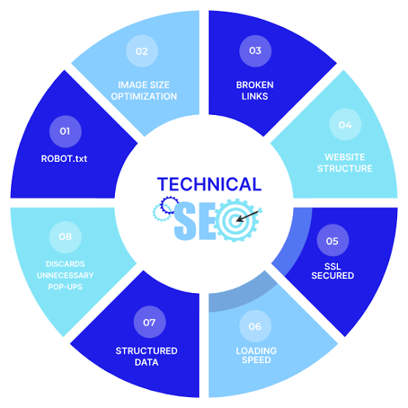
(A) Website Performance & Speed
- Page Load Speed: Needs optimization for faster load times on mobile and desktop.
- Mobile-Friendliness: The website should be fully responsive across devices.
- Core Web Vitals (Google's Metrics): Assessing Largest Contentful Paint (LCP), First Input Delay (FID), and Cumulative Layout Shift (CLS) to enhance user experience.
(B) Indexing & Crawlability
- XML Sitemap & Robots.txt: Ensuring search engines can efficiently crawl and index the pages.
- Broken Links & Redirects: Identifying 404 errors and unnecessary redirects that affect SEO ranking.

2. On-Page SEO Analysis
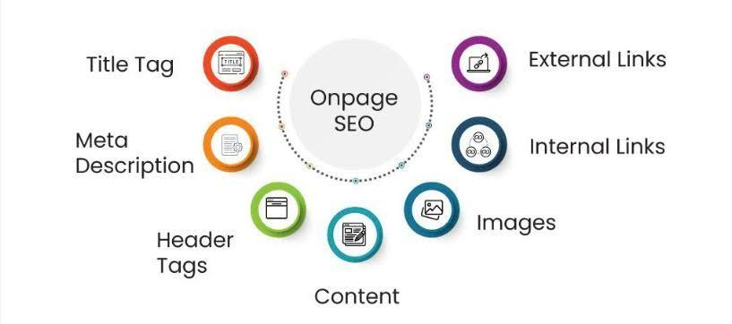
(A) Keyword Optimization
- Primary Keywords: Mahindra SUVs, Mahindra Thar, Mahindra XUV700 price, Mahindra electric vehicles.
- Long-Tail Keywords: Best SUVs in India 2025, Mahindra tractor models, Mahindra EV price.
(B) Meta Tags & Headings
- Title Tags & Meta Descriptions: Each page should have unique, keyword-rich titles and meta descriptions.
- H1, H2, H3 Tags: Ensure proper use of headings for better content hierarchy.
(C) Content Quality & Internal Linking
- Thin or Duplicate Content: Improve pages with low-word content or remove duplicate content.
- Internal Links: Strengthen cross-linking between car models, blogs, and dealerships to boost SEO.

3. Off-Page SEO Analysis
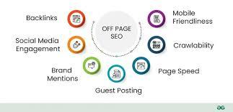
(A) Backlink Profile
- High-Quality Backlinks: Building authoritative backlinks from automotive news sites, blogs, and industry leaders.
- Toxic Backlinks Removal: Identifying and disavowing spammy or low-quality links.
(B) Social Media & Brand Mentions
- Social Signals: Improve engagement on YouTube, Instagram, LinkedIn, and Twitter to boost brand authority.
- Brand Mentions & PR: Enhance digital PR strategies by getting featured in reputable automotive media.

4. Local SEO Analysis


(A) Google My Business (GMB) Optimization
- Location Listings: Ensure all Mahindra dealerships and service centers are properly listed on Google Maps.
- Customer Reviews & Ratings: Encourage positive customer reviews to improve credibility and local search rankings.
(B) Local Keywords & Geo-Targeting
- Keywords like "Mahindra showroom near me" & "Best Mahindra dealer in [City]" should be targeted.
- Localized content for different cities where Mahindra has a dealership presence.

5. SEO Audit Tools Used

- Google Search Console (for indexing & crawlability issues)
- Google Analytics (for traffic & user behavior analysis)
- Ahrefs / SEMrush (for keyword research & backlink analysis)
- PageSpeed Insights (for performance optimization)

Final SEO Recommendations for Mahindra
✅ Optimize website speed to improve mobile & desktop performance.
✅ Strengthen on-page SEO with better keyword targeting & meta descriptions.
✅ Improve internal linking to drive more organic traffic between product pages.
✅ Increase high-quality backlinks from reputable automotive blogs.

Keyword research

Conducting a comprehensive keyword research for Mahindra & Mahindra Ltd. is essential to enhance its digital presence and align with user search behaviors. Below is an analysis of relevant keywords across various categories:

1. Brand-Specific Keywords:
- Mahindra Cars: This term has a global monthly search volume of approximately 201,000, indicating significant interest in Mahindra's automotive offerings.
- Mahindra Car Price: With around 33,100 global monthly searches, this keyword reflects users seeking pricing information on Mahindra vehicles.

2. Model-Specific Keywords:
- Mahindra Thar: A popular SUV model, often searched by users interested in specifications, pricing, and reviews.
- Mahindra XUV700: Another sought-after model, with users looking for details on features, pricing, and availability.

3. Industry-Related Keywords:
- Automobile: A broad term with a global monthly search volume of 1,000,000, relevant to Mahindra's industry.
- Classic Cars for Sale: This keyword has approximately 246,000 global monthly searches, indicating interest in classic automobiles.

4. Long-Tail Keywords:
- Best SUVs in India 2025: Targeting future-oriented buyers interested in top SUV options.
- Mahindra Electric Vehicles: Catering to users interested in Mahindra's electric mobility solutions.

5. Competitor Keywords:
- Tata Motors Cars: Users searching for competitor brands, useful for comparative marketing strategies.
- Maruti Suzuki Models: Another competitor keyword to consider in strategic planning.

6. Geographic-Specific Keywords:
- Mahindra Showroom Near Me: Indicating users looking for nearby dealerships.
- Mahindra Service Center in [City]: Targeting after-sales service queries in specific locations.
Recommendations:Optimize Website Content: Incorporate these keywords naturally into website content, blogs, and product descriptions to improve search engine rankings.
- Monitor Trends: Regularly analyze search trends to adapt to changing user interests and market dynamics.
- Competitor Analysis: Study competitors' keyword strategies to identify opportunities and gaps in your own approach.
By focusing on these targeted keywords, Mahindra can enhance its online visibility, attract a broader audience, and effectively meet user search intent.

On Page optimization
On-Page SEO Optimization for Mahindra & Mahindra Ltd.
On-page SEO focuses on optimizing individual web pages to improve rankings and drive relevant traffic. Below are the key areas of improvement for Mahindra’s website (www.mahindra.com):

A1. Keyword Optimization
✅ Targeted Keywords: Ensure primary and long-tail keywords are integrated into content naturally.
✅ Keyword Placement: Add keywords in title tags, meta descriptions, H1, H2 headings, image alt text, and body content.

2. Meta Tags Optimization
✅ Title Tags:
Example: Buy Mahindra SUVs & Cars – Latest Models & Prices | Mahindra Official Site
✅ Meta Descriptions:
Example: Explore the latest Mahindra SUVs, electric vehicles, and farm equipment. Find prices, specifications, and dealer locations.

3. Header Tags (H1, H2, H3, etc.)
✅ H1 Tag (Main Heading)
Example: Discover Mahindra’s Latest SUVs & Cars – Drive the Future!
✅ H2 Tags (Subheadings)
Mahindra Car Models & Prices
Mahindra Electric Vehicles – The Future of Mobility
✅ H3 Tags (Further Breakdown)
Mahindra XUV700 Features

4. Content Optimization
✅ Unique & Valuable Content: Ensure high-quality, user-focused content (blogs, product descriptions, FAQs).
✅ Internal Linking: Link to other Mahindra product pages, blog posts, and dealer locations to improve site navigation and SEO.

5. Image Optimization
✅ File Names: Rename images with descriptive, keyword-rich names (mahindra-xuv700-blue-suv.jpg instead of IMG123.jpg).
✅ Alt Text: Describe images for SEO and accessibility. Example: Mahindra XUV700 SUV in blue color, side .

6. URL Optimization
✅ SEO-Friendly URLs: Use short, descriptive URLs.
❌ Bad URL: www.mahindra.com/products/2345abc?ref=xyz
✅ Good URL: www.mahindra.com/cars/xuv700

7. Mobile Optimization
✅ Ensure the website is fully responsive on smartphones and tablets.
✅ Test Core Web Vitals (Google’s Mobile Usability Report).

8. Schema Markup (Structured Data)
✅ Implement FAQ schema, product schema, and review schema to improve search results.
✅ Helps in rich snippets like star ratings, price details, and FAQs appearing in search results.

9. Page Load Speed Optimization
✅ Reduce page load time to under 3 seconds.
✅ Use CDNs (Content Delivery Networks) like Cloudflare.
✅ Minimize CSS, JavaScript, and unnecessary plugins.

10. Social Sharing Integration
✅ Add social sharing buttons for users to share Mahindra’s products on Facebook, Twitter, and LinkedIn.
✅ Use Open Graph Tags for better preview on social media.

Final Recommendations for Mahindra’s On-Page SEO
✅ Improve keyword integration across all pages.
✅ Optimize title tags, meta descriptions, and URLs.
✅ Enhance internal linking to increase user engagement.
✅ Fix mobile usability issues and page speed.

Content Idea's and marketing strategies
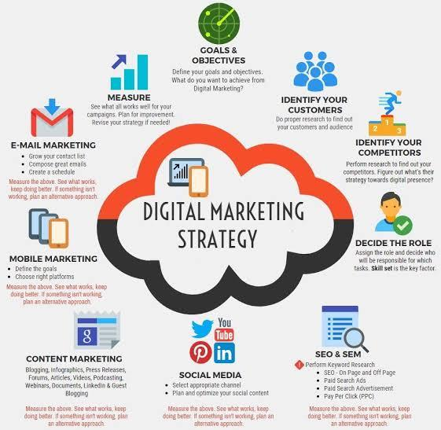
To strengthen Mahindra’s brand presence, customer engagement, and online visibility, we need high-quality content and effective marketing strategies tailored to their target audience.

1. Content Ideas for Mahindra
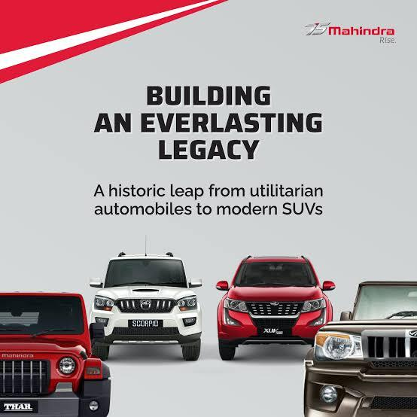
(A) Blog Topics & Articles
✅ Automobile & Mobility
"Why Mahindra Thar is the Best SUV for Off-Roading in India"
"Upcoming Mahindra Electric Vehicles – Future of Sustainable Driving"
"Comparison: Mahindra XUV700 vs Tata Harrier – Which SUV Should You Buy?"
✅ Industry Insights & Trends
"The Rise of Electric Vehicles in India – Mahindra’s Role in EV Revolution"
"How Mahindra is Leading the Indian Automobile Market with Innovation"
Customer-Centric Stories
"Real Mahindra XUV700 Owners Share Their Driving Experience"
✅ How-To Guides & Tips
"How to Choose the Right Mahindra SUV for Your Family"
"5 Maintenance Tips to Keep Your Mahindra Car in Top Condition"

(B) Video Content Ideas
✅ Product Reviews & Walkarounds
Detailed 360-degree video tours of Mahindra’s latest models (Thar, Scorpio, XUV700).
✅ Customer Testimonials & Success Stories
Featuring real Mahindra users and their experiences
✅ Influencer Collaborations
Partnering with auto vloggers & industry influencers to create engaging content.
✅ Off-Roading & Adventure Series
Videos showcasing Mahindra SUVs’ performance in tough terrains like mountains & deserts.

(C) Social Media Content
✅ Instagram & Facebook
Car reels, memes, interactive polls, and behind-the-scenes factory tours.
Twitter & LinkedIn
Industry insights, Mahindra’s sustainability efforts, and new vehicle launches.
✅ YouTube & Shorts
"Mahindra XUV700 ADAS Features Explained"
✅ User-Generated Content (UGC)
Reposting Mahindra owners’ photos & videos from Instagram & Twitter.
Monthly "Best Road Trip with Mahindra" contest where users share road trip experiences.

2. Digital Marketing Strategies for Mahindra
(A) SEO & Search Engine Marketing (SEM)
✅ Optimize website blogs, car pages, and product descriptions with high-ranking keywords (e.g., "Mahindra SUV price," "Best off-road SUV in India").
✅ Run Google Ads & retargeting campaigns for lead generation.Car customization ideas, color options, and Instagram AR filters for Mahindra cars.
(B) Influencer & Affiliate Marketing
✅ Collaborate with automotive influencers on YouTube, Instagram & Twitter.
✅ Partner with auto review blogs like CarDekho, ZigWheels, and AutoCar India.
(C) Email & WhatsApp Marketing
✅ Personalized vehicle offers, service reminders, and new launch updates.
✅ Exclusive pre-booking discounts for new cars via email & WhatsApp.
✅ Monthly Mahindra Newsletter featuring customer stories, new launches & auto industry insights
✅ Facebook & Instagram Ads: Target car buyers, auto enthusiasts & adventure lovers with video ads.
✅ YouTube Ads: Run ads for Mahindra SUVs, new launches & customer testimonials.
✅ Google Display Ads: Promote Mahindra’s electric vehicles (EVs) & financing offers.
(D).Offline & Experiential Marketing
✅ Mahindra Adventure Events: Organize off-roading events & driving experiences to engage customers.
✅ Test Drive Campaigns: Encourage dealership visits & on-road test drives with special offer.

Content Ideas & Strategies for Different Generations – Mahindra & Mahindra Ltd.
To effectively engage diverse audiences, Mahindra should tailor its content strategy to different generations based on their preferences, behaviors, and digital habits. Below is a breakdown of content ideas & marketing strategies for each generation.

1. Generation Z (Born 1997–2012, Ages 12-27)
✅ Tech-Savvy | Social Media Driven | Sustainability-Oriented | Experience Seekr.
Instagram & TikTok Reels: Short, engaging 30-second clips featuring Mahindra SUVs, adventure drives & behind-the-scenes factory tours.
Electric Vehicle (EV) Stories: Showcase Mahindra’s XUV400 EV & future EV plans to appeal to Gen Z’s eco-conscious mindset.
Influencer Collaborations: Partner with auto vloggers, YouTubers, and travel influencers for engaging content.
Marketing Strategies for Gen Z:
✅ Social Media First: Focus on Instagram, TikTok, YouTube Shorts, & Snapchat.
✅ Hashtag Challenges: Create viral challenges like #MahindraOffRoadChallenge.
✅ Memes & Trend Marketing: Use trending memes related to SUV adventures & road trips.
✅ Interactive Instagram Filters: Create AR filters for Mahindra cars allowing users to "test drive" virtually.

2. Millennials (Born 1981–1996, Ages 28-43)
✅ Digitally Connected | Car Enthusiasts | Experience-Oriented | Brand Loyalty Matters
Content Ideas for Millennials:
Car Comparison Blogs & Videos: "Mahindra XUV700 vs Hyundai Creta – Which SUV is Best for You?"
Road Trip Vlogs: Feature travel influencers exploring India in Mahindra vehicles.
Behind-the-Scenes (BTS) Manufacturing Stories: Show how Mahindra SUVs are built.
Sustainability Stories: Promote Mahindra’s electric and green mobility solution.
Marketing Strategies for Millennials:
✅ SEO-Optimized Blogs & Video Content: Create detailed reviews, how-to guides, and ownership experiences.
✅ YouTube & Facebook Advertising: Target potential SUV buyers with Mahindra XUV700 & Thar ad campaigns.
✅ Webinars & Live Q&As: Host Instagram & LinkedIn Live sessions with Mahindra engineers explaining tech features.

3. Generation X (Born 1965–1980, Ages 44-59)
✅ Financially Stable | Practical Buyers | Value-for-Money | Brand Reputation Focused
Content Ideas for Gen X:
Family-Oriented SUV Reviews: "Why Mahindra Scorpio is the Perfect SUV for Indian Families".
Finance & EMI Guides: "Best Car Loan Options for Buying a Mahindra SUV".
Mahindra After-Sales Services: Blogs & videos on warranty, servicing, and maintenance tips.
Customer Success Stories: Showcase long-time Mahindra owners sharing their experiences.
Marketing Strategies for Gen X:
✅ LinkedIn & Facebook Ads: Promote Mahindra’s reliability, resale value & after-sales service.
✅ Email Newsletters: Share product updates, auto industry news, and exclusive offers.
✅ Personalized Financing Offers: Provide customized finance deals & EMI options.

4. Baby Boomers (Born 1946–1964, Ages 60-78)
✅ Traditional Buyers | Value Trust & Service | Prefer In-Person Interaction
Content Ideas for Baby Boomers:
Safety & Comfort Features Explained: Blogs like "Why Mahindra SUVs are the Safest Choice for Indian Roads".
Classic Mahindra Models History: Create content on Mahindra’s heritage, legacy, and past models.
Dealer Event Promotions: Host dealership test drive events, meet-and-greet sessions, and in-person Q&As.
Marketing Strategies for Baby Boomers:
✅ Traditional Media + Digital: Use a mix of TV ads, newspaper articles, and Facebook campaigns.
✅ Personalized Customer Support: Offer direct call support & in-showroom consultations.
✅ Offline Events & Community Engagement: Organize "Mahindra Owners Club" events for long-term customers.
✅ Word-of-Mouth Referrals: Encourage existing Mahindra owners to bring family & friends for test drives.

Final Content & Marketing Strategy Recommendations for Mahindra
1️⃣ Digital-First Approach
✅ Focus on Instagram, YouTube, Facebook & LinkedIn for different audience groups.
✅ Create SEO-driven blogs, video content & influencer partnerships.
✅ Leverage AR/VR for virtual test drives & dealership experiences.
2️⃣ Personalized Marketing & Data Insights
✅ Use Google & Facebook retargeting ads for abandoned leads.
✅ Implement AI chatbots for instant customer queries on Mahindra’s website.
✅ Create regional content in Hindi, Tamil, Telugu, & Marathi for local engagement.
3️⃣ Community-Driven Approach
✅ Launch a "Mahindra Owners Club" for brand loyalty.
✅ Encourage user-generated content – customers sharing Mahindra experiences.
✅ Engage with off-roading & adventure travel communities to promote Mahindra SUVs.

Marketing strategies
Marketing Strategies for Mahindra & Mahindra Ltd.To increase brand visibility, drive customer engagement, and boost sales, Mahindra needs a multi-channel marketing strategy that targets different customer segments. Below is a detailed breakdown of marketing srategy.

1. Digital Marketing Strategies
A) SEO & Content Marketing
✅ Keyword Optimization: Optimize website content with high-ranking keywords like “Mahindra Thar price,” “best SUVs in India,” and “Mahindra electric cars”.
✅ Blog Strategy: Publish weekly blogs on topics such as:
"Mahindra XUV700 vs Tata Harrier .
✅ Localized SEO: Optimize dealership pages for local searches (e.g., “Mahindra showroom near me”).
✅ Voice Search Optimization: Optimize for queries like “best SUV for off-roading” or “Mahindra EV charging stations.”
B) Social Media Marketing
✅ Instagram & Facebook Reels: Short, engaging SUV walkarounds, off-roading adventures, and new launch teasers.
✅ YouTube Reviews & Explainers: Feature product comparison videos, customer testimonials, and expert reviews.
✅ Hashtag Challenges: Launch a viral challenge like #MahindraAdventure, encouraging users to share road trips in Mahindra SUVs.
✅ Influencer Marketing: Collaborate with auto vloggers & lifestyle influencers for authentic product endorsements.
C) Paid Advertising (PPC & Social Media Ads)
✅ Google Ads: Run search & display ads for high-intent keywords (e.g., “Mahindra Scorpio booking,” “best electric SUV in India”).
✅ Facebook & Instagram Ads: Use carousel & video ads showcasing new launches & limited-time offers.
✅ Remarketing Campaigns: Target website visitors who didn’t complete a purchase with personalized ad offers.

2. Offline & Experiential Marketing
A) Dealership Marketing
✅ Test Drive Campaigns: Offer exclusive test drives with incentives like free fuel coupons or discounts.
✅ In-Store Events: Host Mahindra Experience Days featuring live demos, expert Q&A sessions, and early booking offers
B) Event & Sponsorship Marketing
✅ Mahindra Adventure Events: Organize off-roading challenges & road trip expeditions to engage enthusiasts.
✅ Auto Expos & Trade Shows: Participate in major automobile expos (e.g., Auto Expo India, EV Expo) to showcase new models.
✅ Sports Sponsorships: Sponsor motorsports events, cricket leagues, and adventure sports to enhance brand association.

3. Customer Engagement & Loyalty Programs
A) Referral & Loyalty Programs
✅ Mahindra Owners Club: Offer exclusive benefits to repeat customers (discounts, priority service, early access to new launches).
✅ Referral Discounts: Give incentives like ₹5,000 cashback for referring a new customer.
✅ Exchange Offers: Provide attractive exchange bonuses for upgrading old Mahindra vehicles.
B) Email & WhatsApp Marketing
✅ Personalized Offers: Send customized financing options & discounts based on past customer interactions.
✅ WhatsApp Test Drive Booking: Enable quick test drive scheduling via WhatsApp chatbots.
✅ After-Sales Service Updates: Automate reminders for service check-ups, insurance renewals & accessory offers.

4. Future-Ready Strategies (2025 & Beyond)
A) Electric Vehicle (EV) Marketing
✅ Green Mobility Campaigns: Promote Mahindra’s XUV400 EV and future electric models with sustainability-focused ads.
✅ Charging Station Partnerships: Collaborate with EV charging networks to enhance accessibility.
B) AI & Data-Driven Marketing
✅ AI Chatbots for Customer Support: Provide instant query resolution on Mahindra’s website & WhatsApp.
✅ Predictive Analytics: Use AI to analyze customer behavior & suggest personalized vehicle recommendations.
✅ Virtual Test Drives: Implement AR/VR experiences for users to explore Mahindra vehicles from home.

Final Recommendations
✅ Boost Digital Marketing with SEO, influencer collaborations & social media engagement.
✅ Leverage Experiential Marketing through events, road trips & dealership activations.
✅ Expand EV & Sustainable Mobility Awareness with targeted green marketing campaigns.

Content creation and curation

Post creation
To enhance engagement and brand presence, Mahindra should focus on high-quality, engaging, and informative social media posts across platforms like Instagram, Facebook, Twitter, LinkedIn, YouTube, and Pinterest. Below is a detailed post creation strategy tailored to Mahindra’s audience and product range.

1. Types of Social Media Posts for Mahindra
A) Product Highlight Posts
✅ Goal: Showcase Mahindra vehicles’ unique features and benefits.
✅ Platforms: Instagram, Facebook, LinkedIn, YouTube Shorts.
Post Ideas:
- 360° Product Showcases: High-quality carousel posts or videos highlighting SUV features.
- Close-Up Features: Focus on ADAS, infotainment systems, off-road capabilities.
Example Post:
➡ "Meet the Mahindra XUV700 – India’s most advanced SUV with ADAS, a 200 HP turbo engine, and a luxury cabin experience. Would you take it for a test drive 🚗💨 #MahindraXUV700 #LuxurySUV"
B) Customer Stories & Testimonials
✅ Goal: Build trust and showcase real-life experiences.
✅ Platforms: Instagram Stories, Facebook, LinkedIn, YouTube.
- Post Ideas:Real Owners’ Journeys: Share user stories about long road trips in their Mahindra SUVs.
- User-Generated Content (UGC): Encourage customers to share their Mahindra experience with #MyMahindraStory.
Example Post:
➡ "Meet Raj, an adventure enthusiast who just completed a 10,000 km road trip across India in his Mahindra Scorpio N! 🚙🏔️ What’s your most memorable journey Share with #MahindraAdventure!"
C) Adventure & Lifestyle Posts
✅ Goal: Position Mahindra as the best brand for adventure and travel lovers.
✅ Platforms: Instagram Reels, TikTok, YouTube Shorts, Facebook.
Post Ideas:
- Off-Roading Clips: Show Thar & Scorpio N tackling extreme terrains.
- Travel Destination Guides: “Top 5 road trip destinations for your Mahindra SUV”.
- Behind-the-Scenes Factory Tours: Give an inside look at how Mahindra vehicles are made.
Example Post:
➡ "Nothing beats the thrill of off-roading in a Mahindra Thar. Where’s your next adventure 🌍🚙 MahindraThar #OffRoadLife"
D) Industry & Technology Posts
✅ Goal: Educate users on Mahindra’s innovations, sustainability, and EV developments.
✅ Platforms: LinkedIn, Twitter, Instagram, Facebook.
Post Ideas:
- EV Innovation: "Mahindra’s XUV400 – the future of electric mobility is here! ⚡".
- Sustainability Goals: "Mahindra is committed to a carbon-neutral future by 2040. Here’s how we’re making a difference."
- Tech Tuesday Series: Explain Mahindra’s latest car technology (ADAS.
Example Post:
➡ "Did you know Mahindra’s EVs are designed with a range of up to 450 km on a single charge🔋⚡ Say hello to the future with the XUV400. #EVRevolution MahindraXUV400"
E) Fun & Engaging Posts (Memes, Polls, Challenges)
✅ Goal: Increase audience interaction and brand engagement.
✅ Platforms: Instagram, Twitter, Facebook.
Post Ideas:
- Meme Marketing: Create funny off-roading & SUV-related memes.
- Polls & Quizzes: “Which Mahindra SUV matches your personalitized .
Example Post:
➡ "POV: When your friend tells you to take the normal route, but you own a Mahindra Thar. 🚙🤣 #OffRoadKing"
F) Festival & Special Day Posts
✅ Goal: Connect with audiences through cultural relevance.
✅ Platforms: Instagram, Facebook, Twitter, LinkedIn.
Post Ideas:
- Diwali Celebration: "Light up your journey this Diwali with Mahindra XUV700! 🎆🚗 #FestivalOfDrives"
- Independence Day Tribute: Feature Mahindra’s contribution to India’s auto industry.Father’s Day Special: "A Mahindra car is more than just a vehicle – it’s where family memories are made. Happy Father’s Day! #MahindraMemories"

2. Best Practices for Mahindra’s Social Media Posts
✅ Use High-Quality Visuals: Professional car photography, drone shots, and immersive videos.
✅ Write Engaging Captions: Use storytelling, emojis, and call-to-actions (CTAs).
✅ Leverage Trends: Use viral memes, trending audio, and current events to stay relevant.
✅ Post at the Right Time: Peak engagement hours – 7-9 AM, 12-2 PM, 6-9 PM.
✅ Encourage Interaction: Ask questions, use polls, and run contests.

3. Post Calendar Strategy for Mahindra
Final Recommendations
✅ Create engaging product showcases, memes, and adventure posts to captivate the audience.
✅ Leverage customer stories and user-generated content to build community trust.
✅ Use a mix of high-quality images, videos, and reels for maximum engagement.
✅ Follow a structured content calendar to maintain consistency.

Video editing

Video Editing Strategy for Mahindra & Mahindra Ltd.
Creating high-quality, engaging video content is crucial for brand storytelling, product showcasing, and customer engagement. Mahindra’s video editing strategy should focus on crisp storytelling, smooth transitions, high-quality visuals, and engaging sound design to make content compelling across platforms like YouTube, Instagram, Facebook, LinkedIn, and TikTok.

1. Types of Videos Mahindra Should Focus On

A) Product Showcase & Feature Videos

✅ Goal: Highlight vehicle design, features, and performance.

✅ Platform: YouTube, Instagram Reels, Facebook, LinkedIn.

✅ Editing Style:

Cinematic shots with smooth transitions & slow-motion effects.

Example Video Concept:

➡ "Experience the power of the Mahindra Scorpio N – 4X4 capabilities, advanced safety features, and unmatched performance. Watch till the end for a surprise adventure! 🚙🔥"

B) Customer Testimonials & Real-Life Stories

✅ Goal: Build trust and authenticity.

✅ Platform: YouTube, Instagram, Facebook, LinkedIn.

✅ Editing Style:

Use b-roll footage of customers driving their Mahindra vehicles.

Example Video Concept:

➡ "Meet Aman, who took his Mahindra Thar on a 10,000 km road trip across India. Hear his incredible journey and why he trusts Mahindra! 🚗💨 #MahindraAdventure"

C) Off-Road & Adventure Videos

✅ Goal: Show Mahindra’s SUVs in extreme conditions (mountains, deserts, forests).

✅ Platform: YouTube, Instagram Reels, TikTok, Facebook.

✅ Editing Style:
Fast cuts & action-packed transitions to show intensity.
Use GoPro POV shots for an immersive feel.
Add epic background music to build excitement.

Example Video Concept:
➡ "Nothing beats the thrill of off-roading in a Mahindra Thar. Mud, mountains, and pure adventure. Ready for the ride? 🌍🏔️🚙 OffRoadKing.

D) Behind-the-Scenes & Factory Tours
✅ Goal: Showcase Mahindra’s innovation, manufacturing process, and brand values.
✅ Platform: YouTube, LinkedIn, Instagram Stories.
✅ Editing Style:
- Time-lapse & hyperlapse effects for an engaging tour.
- Use voiceovers or CEO talks for an insider perspective.
Example Video Concept:
➡ "From blueprint to beast – Here’s how a Mahindra SUV is built! 🏭🚙 Watch the full behind-the-scenes look inside our state-of-the-art factory. MahindraMakers"
E) Comparisons & Review Videos
✅ Goal: Educate customers on Mahindra’s edge over competitors.
✅ Platform: YouTube, LinkedIn, Facebook.
✅ Editing Style:
- Side-by-side screen splits for easy comparisons.
- Use infographics & motion graphics to highlight specs.

Example Video Concept:
➡ "Mahindra Scorpio N vs Tata Safari – Which is the ultimate SUV? Watch this detailed comparison to find out! 🚗💥 SUVBattle"
F) Viral & Trend-Based Videos
✅ Goal: Create buzz and engage a younger audience.
✅ Platform: Instagram Reels, TikTok, YouTube Shorts.
✅ Editing Style:
- quick jump cuts to keep attention.
- Add trending soundtracks for virality.
- Use text overlays, memes, and emojis to enhance relatability.
Example Video Concept:
➡ "POV: You just got your hands on a brand-new Mahindra XUV700 and hit the road for the first time. 🚀🔥 CarGoals #MahindraLife"

2. Best Video Editing Techniques for Mahindra
A) Cinematic Editing for Product & Off-Roading Videos
✅ Use slow-motion & drone shots for a premium feel.
✅ Enhance contrast & saturation to make the car pops.
B) Engaging Reels & Shorts Editing
✅ Fast cuts & jump cuts to maintain viewer interest.
✅ Text animations & emojis to keep it fun.
✅ Use trending music & sound effects to increase virality.
C) Storytelling Editing for Testimonial & BTS Videos
✅ Keep it authentic & raw – minimal filters.
✅ Use slow zooms & background scores for emotional depath.

3. Recommended Editing Software for Mahindra’s Videos
✅ Adobe Premiere Pro – Best for high-quality cinematic edits.
✅ Final Cut Pro – Smooth performance for Mac users.
✅ DaVinci Resolve – Great for color grading and storytelling.
✅ CapCut/InShot – Quick edits for Instagram Reels & TikTok.
✅ Canva Video Editor – Simple tool for branded animations & text overlays.

4. Distribution & Optimization Strategy
✅ YouTube:
Upload in 4K quality for best visuals.
Add timestamps for long-format videos.
✅ Instagram & TikTok:
Optimize for vertical 9:16 format (Reels, Shorts).
Use catchy hooks in the first 3 seconds.
✅ LinkedIn & Facebook:
Focus on longer, informative content for professionals.
Add closed captions for better engagement.

5. Post-Production Checklist
✅ Step 1: Import high-quality footage & organize clips.
✅ Step 2: Trim unnecessary parts & apply smooth transitions.
✅ Step 3: Add motion graphics, text overlays & branding elements.
✅ Step 4: Enhance audio with background music & sound effects.
✅ Step 5: Apply color grading for a polished look.
✅ Step 6: Export in HD (1080p/4K) and optimize for platforms.

Final Recommendations
✅ Focus on high-energy, adventure-driven edits for SUVs & off-roading videos.
✅ Use fast-paced editing & memes for Reels & Shorts to attract Gen Z.
✅ Leverage cinematic shots, motion graphics & storytelling for product launches.
✅ Optimize videos for YouTube & social media with SEO-friendly titles & tags.

Social media Ad Campaigns

1. Post Creations (Content Strategy for Social Media & Blogs)

A) Social Media Post Ideas (Instagram, Facebook, LinkedIn, Twitter, YouTube Shorts)
✅ SUV & Adventure-Focused Content:
- “The Ultimate Off-Roading Challenge: Mahindra Thar vs Terrain” (Reel/Shorts)
- Behind the Wheel: A Day with Mahindra Scorpio-N Owners
- User-Generated Content: Share photos & videos from Mahindra's.
✅ Electric Vehicles (EVs) Awareness Posts:
- “Myth vs Reality: Are Electric SUVs Better than Petrol SUVs?”
- A Day in the Life with the Mahindra XUV400 EV (Short Video)
- Future of EVs: Mahindra’s Born Electric Range Sneak Peek
✅ Tractor & Farm Equipment Content:
- Meet India’s No.1 Tractor – Mahindra 575 DI!
- Farmer Success Story: How Mahindra Tractors are Transforming Agriculture
- "Smart Farming: The Future of Agriculture with Mahindra Yuvo Tech+"
✅ Commercial Vehicles & Fleet Solutions:
- Why Businesses Prefer Mahindra Bolero Pik-Up for Logistics
- Electric Auto-Rickshaw vs Petrol: What Saves More Money.
✅ Festive & Seasonal Posts:
- "This Diwali, Light Up Your Journey with a New Mahindra XUV700!"
- "Monsoon Adventures: The Best SUVs for Rainy Roads!"
- 📌 Hashtags Strategy: #MahindraSUVs BornElectric #FarmWithMahindra #TharLife #XUV700 #EVRevolution.

2. Designs & Video Editing (Branding & Engagement Strategy)
A) Design Templates & Branding Elements
🎨 Create consistent brand templates for:
- Product launch posts
- Event announcements
- Customer testimonials
- Offer & discount promotions
🎨 Carousel Post Ideas:
- “5 Reasons Why Mahindra Scorpio-N is the King of SUVs”
- “Step-by-Step Guide: How to Charge Your XUV400 EV”
B) Video Editing & Short-Form Video Strategy
- 🎥 YouTube & Instagram Reels/Shorts:
- Behind-the-scenes at Mahindra car factories
- “Thar vs Desert – The Ultimate Off-Road Challenge”
- XUV400 EV: Real-World Mileage Test
- Influencer collaborations: "Drive & Review Series with Auto Experts"
🎥 User-Generated Content & Testimonials:
- Mahindra SUV Owners Share Their Road Trip Experiences
- Real Farmers Using Mahindra Tractors – Success .
📌 Editing Style: Use dynamic cuts, high-energy transitions, and motion graphics to make content engaging.

3. Ad Campaigns (Social Media & Performance Marketing)
A) Paid Social Media Campaigns (Meta Ads, Google Ads, YouTube Ads)
✅ Awareness Campaigns:
- “Experience Adventure with Mahindra Thar – Book a Test Drive Now!” (Instagram, Facebook, YouTube)
- “The Future of SUVs is Here – Check Out the XUV700!”
- “Switch to Electric! Special Offers on Mahindra XUV400”
✅ Lead Generation & Retargeting Ads:
- Target audience: SUV enthusiasts, rural farmers, commercial fleet owners
Ad formats:
- Lead forms (Book a test drive, get a price quote)
- Carousel Ads (Showcasing different Mahindra models)
- Video Ads (Explainer & testimonial ads on YouTube & Facebook)
B) Google Ads & Search Engine Marketing (SEM)
✅ Keyword Targeting:
- “Best tractor for farming in India” (Mahindra 575 DI vs John Deere)
- “Electric car with highest mileage in India” (XUV400 vs Tata Nexon EV)
✅ Search & Display Ad Strategy:
- Google Search Ads: High-intent buyers searching for Mahindra models
- YouTube Video Ads: Pre-roll ads targeting automobile lovers
📌 Ad Budget Allocation:
- 50% for SUV & EV awareness
- 30% for tractor & commercial vehicles
- 20% for lead generation & retargeting

4. Email Ideation & Creation (Lead Nurturing & Customer Engagement)
“Best SUV under ₹20 lakhs” (XUV700 targeting Tata Safari)
✅ Types of Email Campaigns:
📩 Product Launch Emails:
- “Introducing the Mahindra Born Electric SUVs – Get Exclusive Updates!”
- “XUV700 Now Available with ADAS – Book a Test Drive Today!”
📩 Customer Engagement Emails:
- “Your Mahindra Adventure Begins Here – Join the Mahindra SUV Community!”
- “Best Road Trips for Your Thar – Get Inspired”
- “5 Tips to Maintain Your Mahindra EV for Longer Battery Life”
📩 Personalized Offers & Discount Emails:
- "Exclusive: Special Offers on Mahindra Scorpio-N for Festive Season"
- "Upgrade to an Electric SUV & Save ₹X on Fuel Costs!"
📩 After-Sales & Customer Retention Emails:
- "Time for Your First Free Service – Schedule Now!"
- "Your XUV700 is Due for a Software Update – See What's New!”
📌 Email Design & Strategy:
- High-quality visuals & GIFs for engagement
- A/B testing on subject lines & CTAs
- Segmentation: Different campaigns for SUV buyers, EV enthusiasts, farmers, fleet owners
Final Deliverables & Execution Plan
✅ Content Calendar:
- Plan posts, videos & emails for the next 3 months
- Schedule & automate social media & email campaigns
✅ Ad Performance Tracking:
- Set up UTM tracking for campaigns
- Monthly SEO & paid ad performance reports
✅ Creative Assets:
- Pre-designed post templates, ad creatives, video thumbnails
✅ Engagement & Community Building:
- Reply to comments, encourage user-generated content (UGC)
Next Steps:
1️⃣ Finalize content themes (SUVs, EVs, tractors, commercial vehicles)
2️⃣ Design sample posts, videos & email templates
3️⃣ Set up ad campaigns & analytics dashboards
4️⃣ Launch & optimize based on performance insights

Conclusion:
Through strategic investments in electric mobility, digital transformation, and advanced manufacturing, Mahindra is positioning itself as a future-ready organization. Its commitment to customer satisfaction, rural development, and green initiatives further reinforces its brand value.
Overall, Mahindra & Mahindra remains a powerhouse in the Indian and global markets, driving progress through innovation, sustainability, and a customer-centric approach.

